Project Code Explanation

Importing Libraries
The code begins by importing pandas, numpy, matplotlib, and seaborn. These libraries are used for data manipulation, numerical computations, and visualization.

Loading the Dataset
The dataset is loaded using pd.read_csv(), which reads the CSV file into a DataFrame named data.
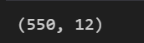

Viewing Dataset Structure
Functions like data.shape, data.head(), and data.tail() are used to understand the number of rows/columns and preview the dataset.
HEAD:
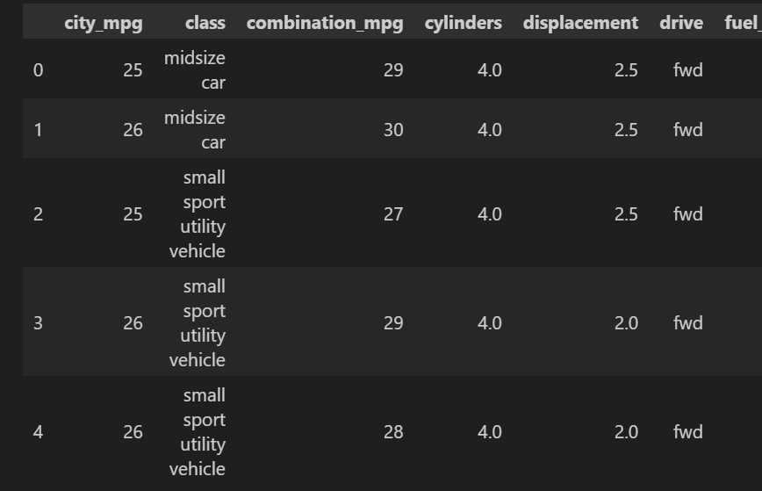
TAIL:
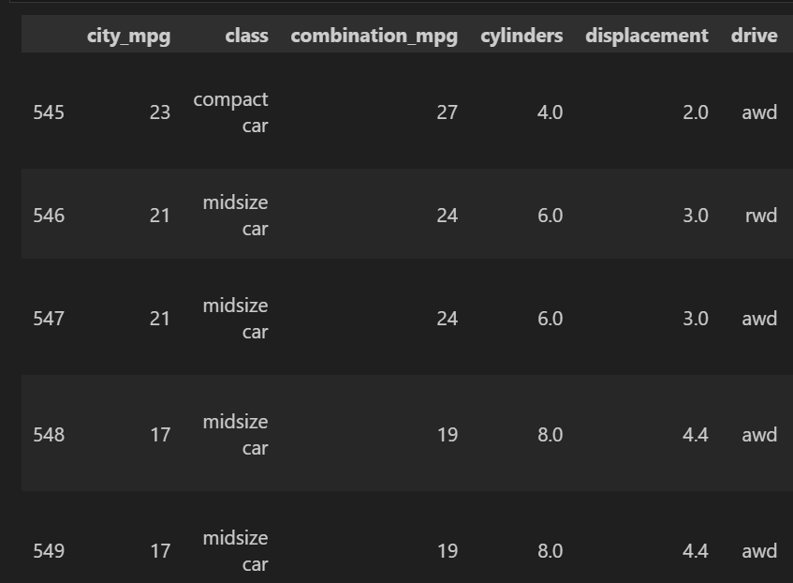

Dataset Summary
data.info() and data.describe() help identify column types and basic statistical measures such as mean, median, and standard deviation.
INFO:
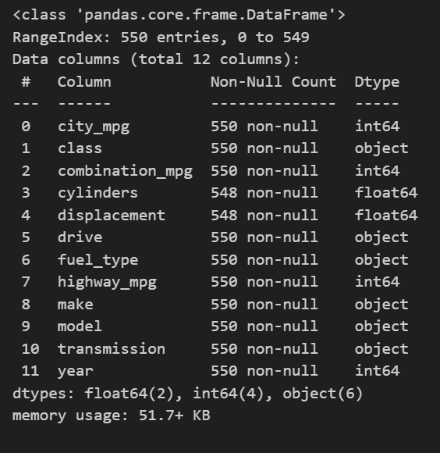
DESCRIBE:
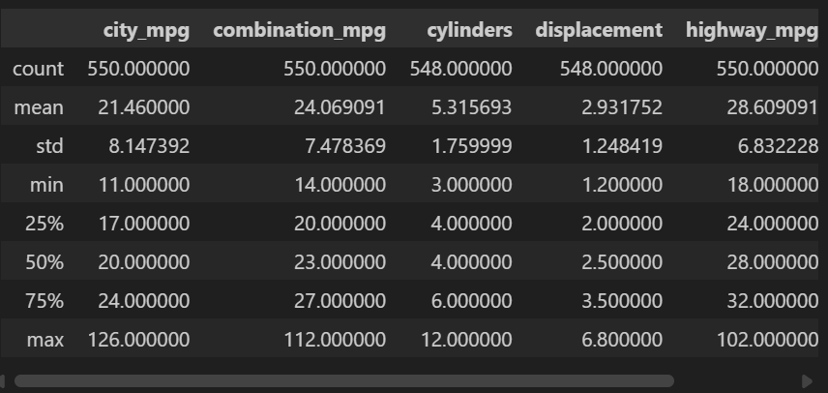

Handling Missing or Duplicate Values
The code checks for missing values using data.isnull().sum() and duplicates using data.duplicated().sum().
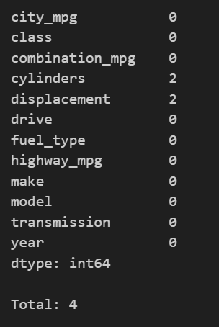

Correlation Analysis
data.corr() calculates correlations between numerical columns, helping identify relationships between variables.

Pairplot Visualization
sns.pairplot(data) generates scatterplots and histograms to visualize relationships between multiple variables.

Distribution Plots
sns.distplot(data['city_mpg']) visualizes the distribution of city mileage values to see the spread and shape.
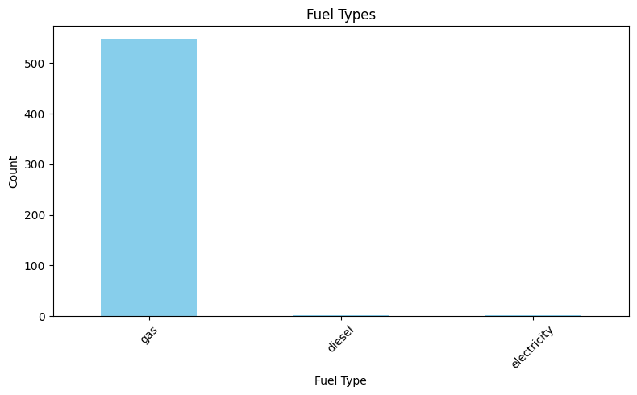

Histogram Plot
plt.hist() is used to plot frequency counts of city mileage, showing how often values occur.
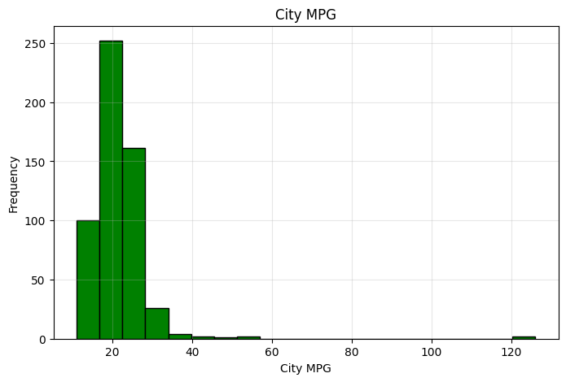

Scatter Plot
The scatter plot compares city and highway MPG to analyze their relationship.
